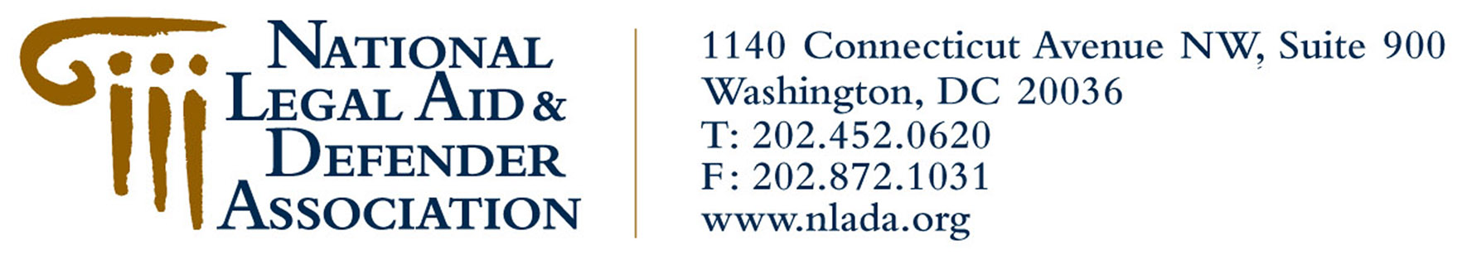 Fact Sheet

Organization: National Legal Aid & Defender Association

Location: 1140 Connecticut Avenue, NW, Suite 900
Washington, DC 20036
Phone: (202) 452-0620
Fax: (202) 872-1031

Established: 1911

Management: Jo-Ann Wallace, President and CEO
Julie Clark, Vice President for Strategic Alliances
Charles Wynder, Jr., Vice President for Program Leadership and Support
Deborah Dubois, Vice President for Marketing, Communications & Development
Betty Johnson, Executive Office Administrator

Organizational The National Legal Aid & Defender Association (NLADA) is the oldest and
Focus: largest national, nonprofit membership organization devoting all of its resources to advocating equal justice for all Americans. NLADA champions effective legal assistance for people who cannot afford counsel, serves as a collective voice for both civil legal services and public defense services throughout the nation and provides a wide range of services and benefits to its individual and organizational members.

Membership: NLADA membership consists of two groups: 1) Organizations providing direct service and support in the areas of civil legal aid and public defense; and 2) Individuals within and outside the equal justice community.

Program Local and statewide civil legal aid and public defender offices, national support
Members: centers and public interest groups, pro bono programs, bar associations, Interest on Lawyers Trust Account (IOLTA) programs, social service organizations, corporate legal departments and law firms.

Individual Civil legal aid and indigent defense advocates (attorneys, social workers, etc.) bar Members: association leaders and staff, private practice attorneys, judges, law school
clinicians and faculty, pro se facilitators, paralegals, clients, law students and private citizens who support the pursuit of equal access to justice.

Unique NLADA serves the legal aid community in two major ways: 1) serves as
Characteristics: the leading national voice in public policy and legislative debates on the many
issues affecting the equal justice community; and 2) provides first-rate training, products and services to members.

Media Jeff Billington
Contact: Deputy Director of Communications
(202) 452-0620, ext. 230
j.billington@nlada.org

