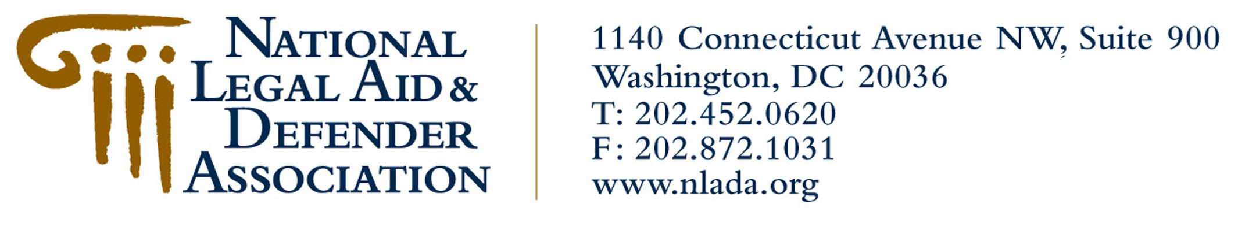Frequently Asked Questions

civil legal aid

What is civil legal aid?

• Civil legal aid refers to the free legal services provided by thousands of attorneys who work through local legal aid offices to help millions of low-income people gain access to justice.

• Civil legal aid helps low-income people resolve urgent, non-criminal legal problems that make a difference in their everyday lives, such as protecting the elderly from unlawful evictions, making sure women and children are protected from violence in their homes, and helping veterans receive the financial benefits they have earned and need.

How is civil legal aid funded?

• Civil legal aid programs are state-based or community-based organizations funded in a variety of ways. Some receive grants from Congress each year through the Legal Services Corporation (LSC). The LSC is a private, nonprofit organization established by Congress to ensure equal access to justice under the law by providing legal assistance in civil (non-criminal) matters to low-income individuals.

• Most federally funded civil legal aid programs also receive support from other sources, including individual donors, foundations, businesses, United Way contributions, state bar foundations and state and local governments.

• Many civil legal aid programs do not receive any federal funds and are completely reliant on private donations and state and local government funding.

• Many programs now rely on funds provided through Interest on Lawyers’ Trust Accounts (IOLTA). These accounts are funded through interest accrued on legal trust accounts, which consist of legal fees placed in escrow.

• Even IOLTA funds are not safe from legal aid opponents, who have argued that the accounts are not voluntary, opt-in programs for legal clients. They have used this argument as the basis of legal challenges to IOLTA. If these challenges are successful, millions of dollars in funding will be taken away from legal aid programs across the country.

Who is served by civil legal aid?

• Clients of civil legal aid represent the diversity that is America — encompassing all races, ethnic groups and ages, ranging from veterans and family farmers to the urban low-wage workers and victims of natural disasters.

(more)

Page 2, FAQs on Civil Legal Aid…

• Civil legal aid attorneys handle millions of cases each year, helping the more than 40 million people in this country living at or below the poverty level. Federal funds are used in approximately 1.5 million of these cases.

• More than two-thirds of civil legal aid clients are women, and most of them are mothers. Because of this, the legal problems of people living in poverty can have serious implications for children.

• In 1996, civil legal aid programs across the country handled more than 50,000 cases in which the primary issue was protection from domestic abuse and violence.

Why is there a need for civil legal aid?

• Despite relatively prosperous times, more than 35 million Americans are still living below the poverty level, and another 10 million have incomes that are less than 25 percent higher than that level. As a result, roughly one in six U.S. citizens is eligible for federally funded legal services.

• There are more than 19 million low-income households in the U.S. Using the average level of need
found in the ABA study (1.1 per household), this means that low-income people experience at least
20 million legal problems per year. Studies performed in states by the Legal Services Corporation
indicate that the true number may be well in excess of 20 million.

• Most low- and moderate-income people feel shut out from the legal system. They do not turn to the courts for solutions because they believe the system will not help them.

• Civil legal aid ensures justice for all Americans, regardless of their income. Many people would otherwise not be able to afford access to the courts to resolve their legal troubles.

• The American Bar Association has estimated that despite serving 1.9 million clients in 1997, the collective civil legal aid effort is meeting only about 20 percent of the legal needs of low-income people.

